

[www.TaubliebConsulting.com](http://www.TaubliebConsulting.com)

**Charlie Taublieb**

6122 South Boston Circle  
Greenwood Village, Colorado 80111  
Cell 303-618-8955

WhatsApp +1-303-618-8955

Academy of Screen & Digital Printing Technologies

_________________________________________________________

## High Density Inks and Gels

High Density Inks and Gels have been around for a while now and they have evolved considerably since their early stages. Not only have the inks changed, but the materials for working with them. Let’s look at some of the products that make working with them easier and more interesting.

The first things are the inks and gels themselves. They are softer and easier to print with once they are stirred. The variety of gels seems to increase on a regular basis. There are many clear gels with some being very clear as opposed to yellowing. There are clear gels that are stiff and allow for easy stacking. These usually require fairly high temperatures through the dryer to completely flow. If a small quantity of pigment or ink is added to them and then run through the dryer at a lower temperature, they appear as though they are a high-density ink instead of a gel. There are gels that stack well and flow at low temperatures to make it easier for those without long dryers to work with gels. These can also have color added, but it’s a little trickier to get them to look like an ink. Gels are available that look like liquid silver or as though they have glitter in them. These can also have a little pigment added to change their color without affecting the shine. Some of the easy flowing gels can be used for caviar beadwork and also as an adhesive for flock and foil transfers.

The next product is the capillary film being used. When high density was first introduced, the thickness of the capillary film that was recommended was 100-300 microns. With the evolution of the inks, gels and mesh, it is not uncommon to use 100-400 micron film for inks and 300-700 micron film for gels with some companies working with 1000 microns. One of the important elements in working with the thicker films is the mesh. Initially, most work was being done through an 86-110 mesh. Now the mesh of choice is an 83 mesh with 70-micron thread. There is also 80SS mesh, which is 80 mesh with a 70-micron thread and even a 70SSS, which is 70 mesh with 70-micron thread. The thin thread diameter creates a large percentage of open area and the inks and gels can clear through the mesh much easier. The newest rage is working with wire mesh. The size being used is an 80-wire mesh and because it is made of metal, the gels seem to not adhere to it and the result is a gel printing through a 1000 micron film with one pass. Of course, technique is something that has to be developed by the individual printer.

Items for printing with make up the end of this article. Traditionally, squeegees were used to print with. Generally, a soft, sharp blade with enough pressure to have the ink or gel clear the mesh in one or two passes. On automatics, a triple durometer 65/90/65 squeegee was used with a medium-slow print stroke. The use of a 55/90/55 squeegee is even a better option for manual or automatic printing.

To achieve certain looks, it is feasible to use brushes. These can be used to move caviar beads through a screen so the hand process is eliminated. The bead size is usually a 25/35 bead being printed through

a 13-19 mesh. Brushes can also be used to print high-density inks and gels. The results are interesting with prints looking similar, but not the same.

With a little experimenting and creativity, there is no telling what products and techniques will come up with next.

Variety of high density effects on one design including ink in the air.

Duct tape, electrical tape and masking tape on one design.

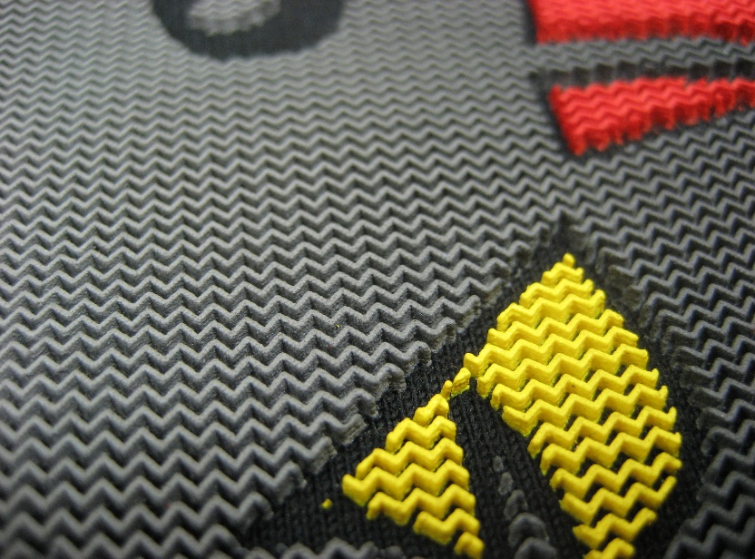

Multiple layers of ink using 200 micron film and a color blend used for this design.

Brush technique plus blister base. Multicolor on black plus brush work.

Wallpaper brush trimmed down. Thick capillary film close-up.